Ysgol y Wern
Llangranog Road
Llanishen
02920762114
ysgolywern@cardiff.gov.uk
27/11/20
Dear Parent/Carer,
Data collection activity (2020): Service children
At Ysgol y Wern we are committed to understanding the needs and supporting all our learners with their unique experiences throughout education. One such group that we aim to support is children of Armed Forces personnel.
Our school recognises that the child of a Service family may at some point in their lives need support with their learning/settling into new situations and/or mental health and wellbeing, as a result of their unique circumstances. This could be due to mobility, deployment, transition, education and/or social needs.
Part of our support for Cardiff Council’s commitment to the Armed Forces Covenant involves identifying our Service children so that we can support them appropriately.
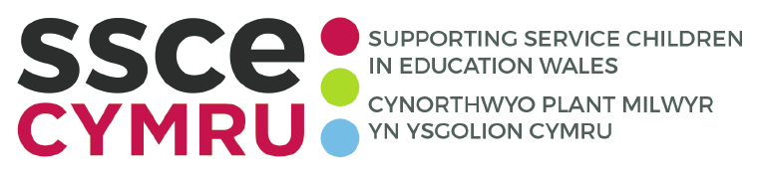

The SSCE Cymru mission is to provide the best possible educational support to Service children in Wales. SSCE Cymru works collaboratively with organisations across the UK to build an evidence base that impacts policy and systems. The programme also provides a suite of resources to support education professionals and Service families across Wales, including toolkits and tool, good practice examples, newsletters, funding guidance and a directory of support. For further information, visit www.SSCECymru.co.uk
By identifying the number of Service children in Ysgol y Wern we can be proactive in identifying their needs, making support available and accessing funding if required.
Please help us to gain an understanding of our Service community by completing the below form and returning it to the school by 21st December 2020. We encourage all families to return the completed form, to indicate if they are part of an Armed Forces family or not.
We will then be able to share the total number of Service children enrolled at our school with the local authority and SSCE Cymru. In line with GDPR guidelines, all names and identifying characteristics of children will remain confidential.
Kind regards

M. Kellaway
Headteacher
(Ysgol y Wern)

Data collection activity (2020): Service children
Parent/carer return form

Definition 1 (Welsh Government definition)
A ‘Service child’ has parent(s) – or person(s) with exercising parental responsibility – who is/are Service personnel serving:
- in HM Regular Armed Forces
- in full commitment as part of the full-time Reserve service
- is a veteran who has been in Service within the last two years
- one of their parents died whilst serving in the Armed Forces and the pupil receives a pension under the Armed Forces Compensation Scheme or the War Pensions Scheme.
Definition 2
A person whose parent, or carer, serves in the regular armed forces, or as a reservist, or has done at any point during the first 25 years of that person’s life. *and does not meet the criteria of definition 1.

Does your child/ren fit within either of the above definitions of a Service child (please only select one option)?
☐ Yes – definition 1
☐ Yes – definition 2
☐ No

Which Service are your family connected to?
☐ Royal Navy/Royal Marines
☐ British Army
☐ Royal Air Force
☐ Veteran/ex-Service personnel
☐ N/A

Pupils name(s) – list all if more than one child at the school:
Click or tap here to enter text.
Click or tap here to enter text.
Click or tap here to enter text.

Year group – list all if more than one child at the school:
Click or tap here to enter text.
Click or tap here to enter text.
Click or tap here to enter text.

To be returned to ysgolywern@cardiff.gov.uk by 21st December 2020.

